Batch:_____B2____ Roll No.:___1611103____
Experiment No. 9
Grade: AA / AB / BB / BC / CC / CD /DD

Title:
Implementation of Hashing using collision resolution methods linear and quadratic probing.

Objective:

Expected Outcome of Experiment:

CO | Outcome
3 | Demonstrate sorting and searching methods

Books/ Journals/ Websites referred:

Data Structures Using C By Reema Theraja.
Related Theory:-

present but can be used to hold a value.
When a key is mapped to a particular memory location, then the value it holds is checked. If it
contains a sentinel value, then the location is free and the data value can be stored in it. However,
if the location already has some data value stored in it, then other slots are examined systematically
in the forward direction to find a free slot. If even a single free location is not found, then we have
an OVERFLOW condition.
The process of examining memory locations in the hash table is called probing. Open addressing
technique can be implemented using linear probing, quadratic probing, double hashing, and
rehashing.
Linear Probing
The simplest approach to resolve a collision is linear probing. In this technique, if a value is already
stored at a location generated by h(k), then the following hash function is used to resolve the
collision:
h(k, i) = [h￠(k) + i] mod m
Where m is the size of the hash table, h￠(k) = (k mod m), and i is the probe number that varies from
0 to m–1.
Therefore, for a given key k, first the location generated by [h￠(k) mod m] is probed because for
the first time i=0. If the location is free, the value is stored in it, else the second probe generates
the address of the location given by [h￠(k) + 1]mod m. Similarly, if the location is occupied, then
subsequent probes generate the address as [h￠(k) + 2]mod m, [h￠(k) + 3]mod m, [h￠(k) + 4]mod m, [h￠(k)+ 5]mod m, and so on, until a free location is found.
Quadratic Probing
In this technique, if a value is already stored at a location generated by h(k), then the following
hash function is used to resolve the collision:
h(k, i) = [h￠(k) + c1i + c2i2] mod m
where m is the size of the hash table, h￠(k) = (k mod m), i is the probe number that varies from 0 to
m–1, and c1 and c2 are constants such that c1 and c2 π 0.
Quadratic probing eliminates the primary clustering phenomenon of linear probing because
instead of doing a linear search, it does a quadratic search. For a given key k, first the location
generated by h￠(k) mod m is probed. If the location is free, the value is stored in it, else subsequent
locations probed are offset by factors that depend in a quadratic manner on the probe number i.
Although quadratic probing performs better than linear probing, in order to maximize the utilization
of the hash table, the values of c1, c2, and m need to be constrained.

Code:-

#include<iostream.h>
#include<conio.h>
#define M 11
int h(int x)
{
return x%M;
}
int ReHashLP(int key,int y,int ht[])
{
int j = 1;
for(int i = 0;i < M;i++)
{
if(ht[(h(key) + j)%M] == -1)
return (y + j)%M;
else
j++;
}
//cout<<"Overflow of data\n";
return M + j;
}
int ReHashQP(int key,int y,int ht[])
{
int j = 1;
for(int i = 0;i<M;i++)
{
if(ht[( h(key) + j*j)%M] == -1)
return (y+j*j)%M;
else
j++;
}
//cout<<"Overflow of data\n";
return M + j;
}
int HashSearch(int key,int ht[])
{
int y = h(key);
if(ht[y] == key)
return 0;
else
{
for(int i = 0;i<M;i++)
{
if(ht[i] == key)
if(i == 0)
return M;
else
return i;
}
return M + i;
}
}
int main()
{
clrscr();
int HashTableLP[M],HashTableQP[M],input,hs;
for(int i = 0;i<M;i++)
HashTableLP[i] = HashTableQP[i] = -1;
cout<<"Enter the total elements in hash table(should be less than 11) : ";
cin>>hs;
if(hs > 11 )
return 0;
for(i = 0;i<hs;i++)
{
cout<<"Enter the data: ";
cin>>input;
if(HashTableLP[h(input)] == -1)
HashTableLP[h(input)] = input;
else
HashTableLP[ReHashLP( input, h(input) , HashTableLP )] = input;
if(HashTableQP[h(input)] == -1)
HashTableQP[h(input)] = input;
else
HashTableQP[ReHashLP( input, h(input) , HashTableQP )] = input;
}
cout<<"Enter the data to searched : ";
cin>>input;
cout<<"Using Linear Probing........\n";
hs = HashSearch(input,HashTableLP);
if( hs == 0 )
cout<<"Element found at ( in O(1) ): "<<h(input)<<endl;
else
if( hs > M )
cout<<"Element not found"<<endl;
else
cout<<"Element found at ( after probing ) : "<<hs%M<<endl;
cout<<"Using Quadratic Probing.....\n";
hs = HashSearch(input,HashTableQP);
if( hs == 0 )
cout<<"Element found at ( in O(1) ): "<<h(input)<<endl;
else
if( hs > M )
cout<<"Element not found"<<endl;
else
cout<<"Element found at ( after probing ) : "<<hs%M<<endl;
getch();
return 0;
}

OUTPUT:-

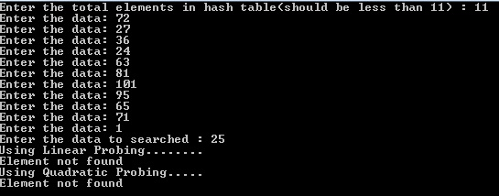

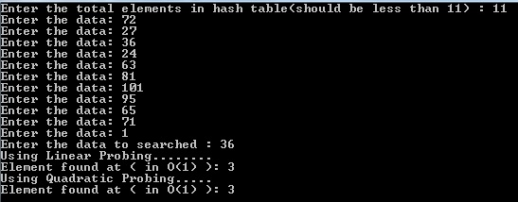

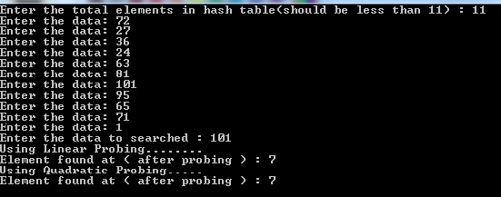

Implementation Details:
- Enlist all the Steps followed and various options explored
Ans. First a hashing function is created that returns the mod m value of the key passed. Then we check if any value exits at that point or not. If exists we use the Rehashing concept of collision and use linear & quadratic probing. Also it searches the element entered. If found at the hashed index then shows O(1) complexity or else uses linear search to find the element in the table.

- Explain your program logic, classes and methods used.
Ans. int h(int x) :
A function which returns the index at which the key is to be inserted. Also known as hashing function.
int ReHashLP(int key,int y,int ht[]) :
A function which returns the rehashed index for ht hash table using linear probe.
int ReHashQP(int key,int y,int ht[]) :
A function which returns the rehashed index for ht hash table using quadratic probe.
Int hs(int key, int ht[]) :
A function which returns 0 if element is at h(key) else finds the data using linear search. It returns a value greater than M/11 if element is not present in the table.
- Explain the Importance of the approach followed by you
Ans. In the approach followed the max. size of hash table is set to 11/ M.
The elements entered are then hashed accordingly and stored in the table array but we report Overflow when the entered number of data is more than the size of array/M/11. Also the searching function returns a value greater than M if element is not found.

Conclusion:-
Hence the hash functions with collisions are studied and implemented.

